**Cinema Hall Ticket Management System**

**Introduction**

Welcome to the user documentation for our Cinema hall ticket system. This comprehensive guide is designed to assist cinema hall managers and clients in effectively utilizing our website to manage and streamline their activities.

Our Cinema hall ticket system is a powerful tool that enhances efficiency, organization, and collaboration throughout the entire ticketing process.

This user documentation will guide you through the system’s process, provide an overview of the system's user interface, and offer detailed instructions on how to perform various tasks and utilize different features. Additionally, it will address common troubleshooting scenarios and answer frequently asked questions to help you navigate any challenges that may arise.

**User interface overview**

The user interface (UI) of our Cinema hall ticket system is designed to provide a user-friendly and intuitive experience, allowing you to efficiently navigate and access the system's features.

**Getting Started Guide**

This getting started guide will walk you through the essential tasks and workflows in our Legal Case Management system. By following these step-by-step instructions, you will quickly become proficient in using the system to manage your movies being shown.

**Homepage**



**Signing up**

* Open your preferred web browser and navigate to the sign up page of our Cinema hall ticket system
* Enter your name, telephone number, email and password.
* Click the "Sign up" button to register into the system.

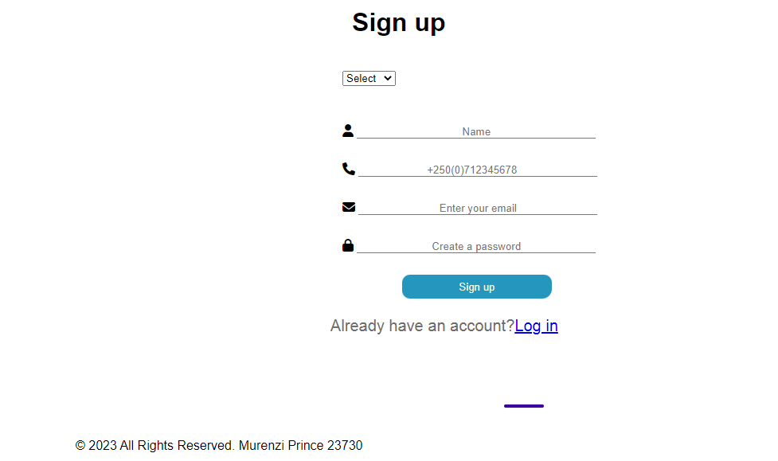

**Logging In**

* Enter your email and password
* Click the "Login" button to access the system.



**Navigating the Dashboard**

* Upon logging in, if you are the Admin you are redirected to a page with a list of all movies in the database with the options of updating and deleting the data or adding a new one
* Take a moment to familiarize yourself with the widgets and sections on the dashboard.
* Click on the different links and buttons to explore the functionality available directly from the dashboard.

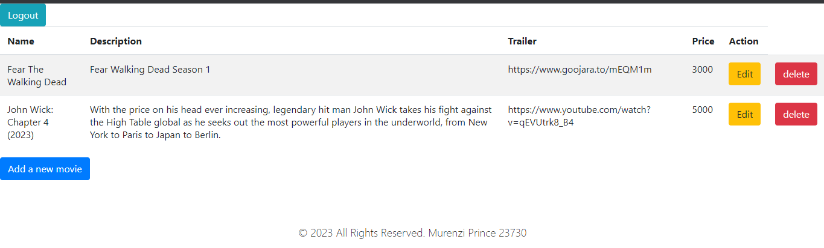

Adding a new movie

* Click on the "Add a new movie" button to initiate the process.
* Enter the required information, such as movie’s name, movie’s description, the link of its trailer, and its ticket price.
* Save the movie.

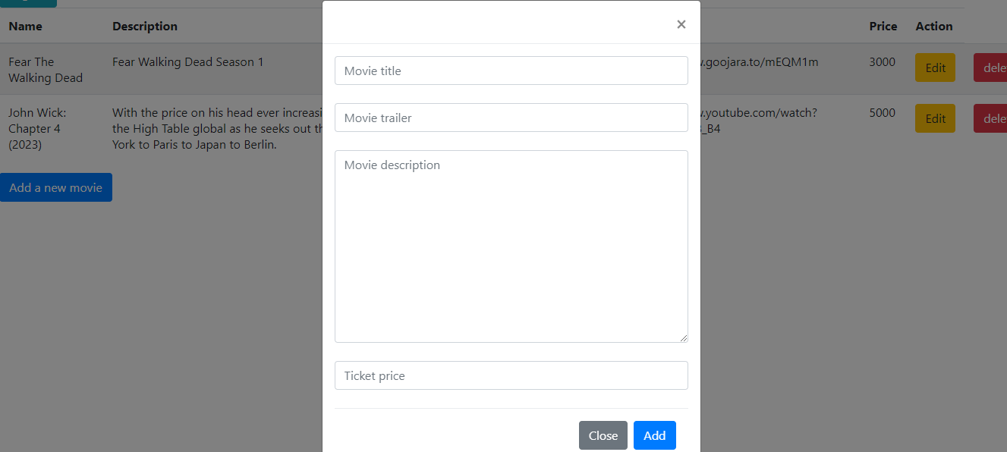

**Updating saved data**

* Locate the "Edit" button.
* Click on the "Edit" button.
* Enter all details
* Save

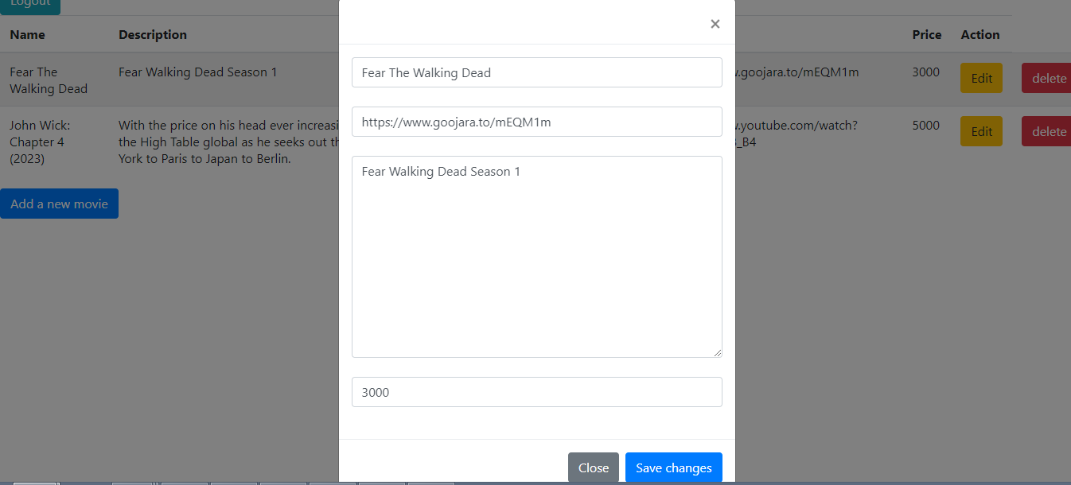

* Upon logging in, if you are the User you are redirected to a page with a list of all movies in the database with the options of playing the trailer and buying a movie ticket.
* Take a moment to familiarize yourself with the widgets and sections on the dashboard.
* Click on the different links and buttons to explore the functionality available directly from the dashboard.

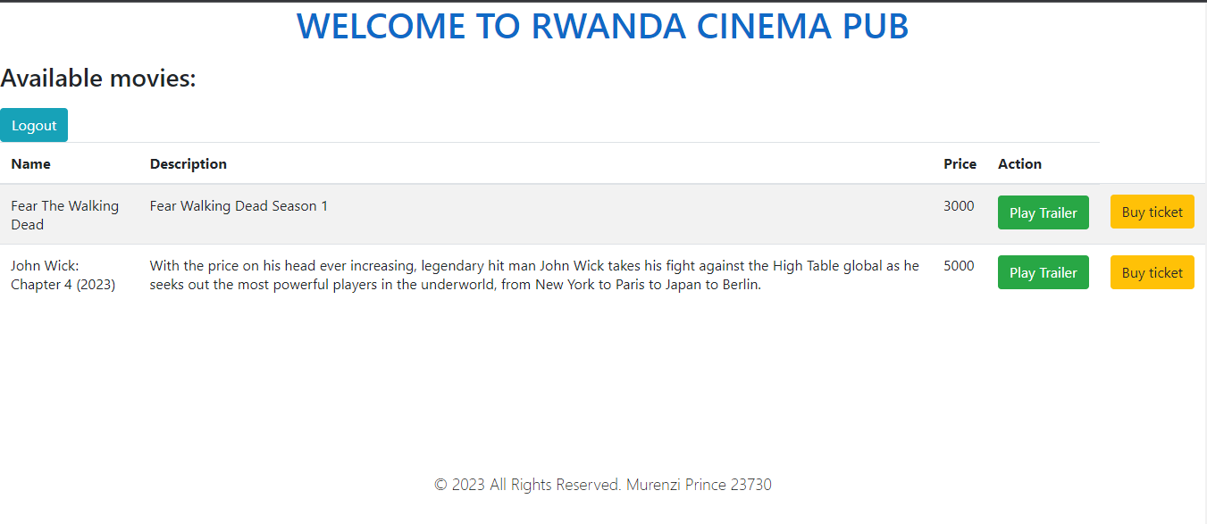

Troubleshooting

System Login Issues:

* Double-check your username and password for accuracy.
* Ensure that you have a stable internet connection.
* Clear your browser cache and cookies, then try logging in again, contact your system administrator if the issue persists.